Git & Git Hub – 01
To check if git is already installed and is of which version.
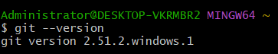
By simply type git –version it show the version

To initialize and create a new empty directory with .git extension
git init
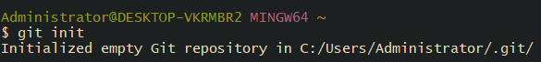
git init → Converts your folder into a Git repository so Git can start tracking your files.
To check the changes in the directory we use command
git status.
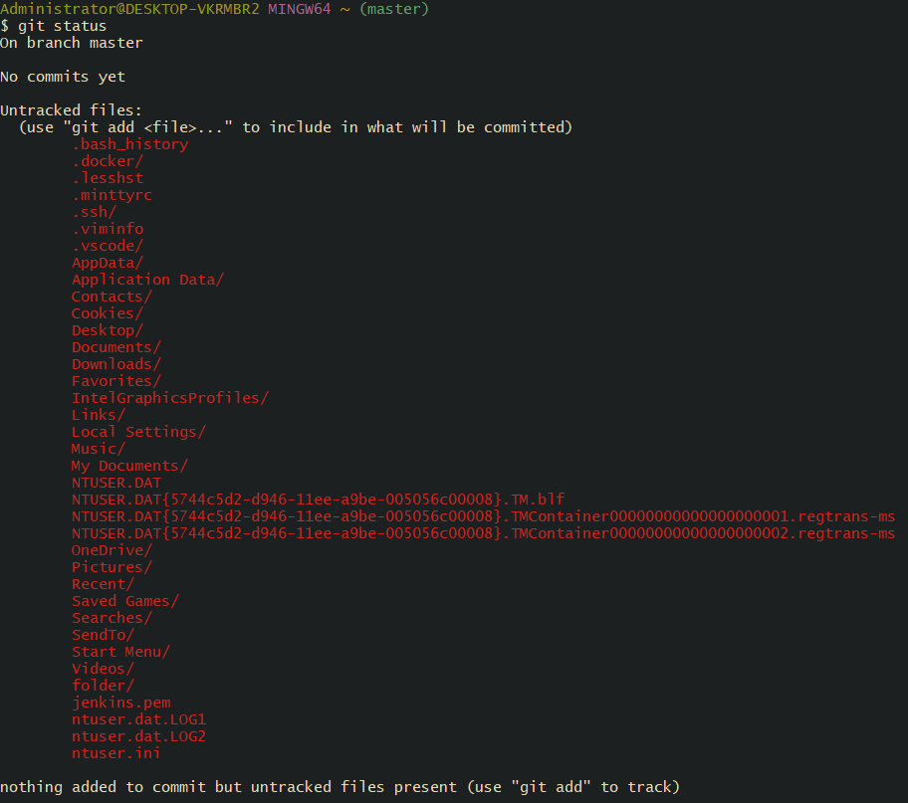
git status → Shows what changed in your folder (new, modified, or untracked files).
To list the initialized files, we use ls -a command
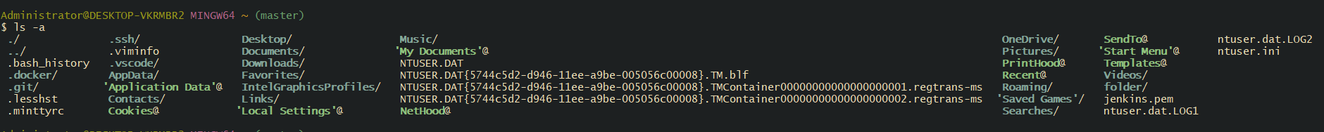
ls -a → Shows all files, including hidden files (like .git).

Cd .git/ it is a directory created after initializing and is consists of configurations related things
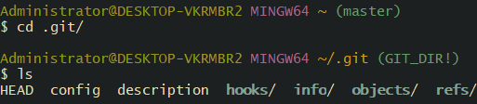
cd .git/ → Moves inside the hidden .git folder, which contains all Git configuration

To get all the details about git use command
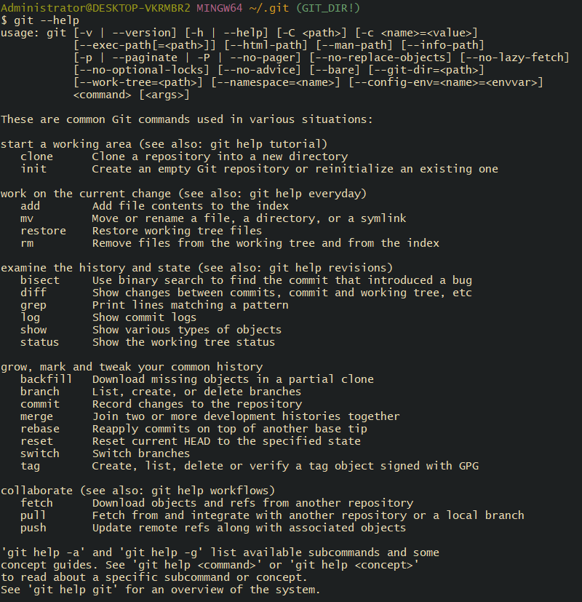

git --help → Shows all Git commands and complete Git documentation.
If you want Git configuration details, use:
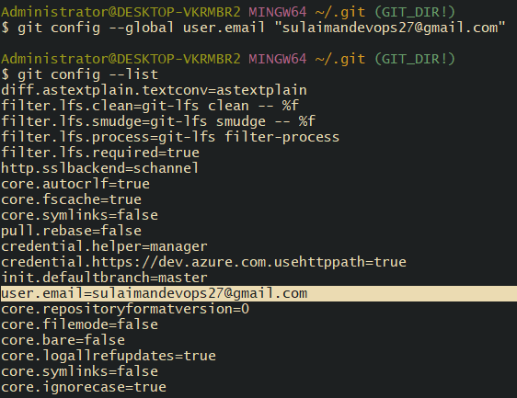

In order to push the file to central repository, we need to move files
from untracking area to tracking area.
git add filename
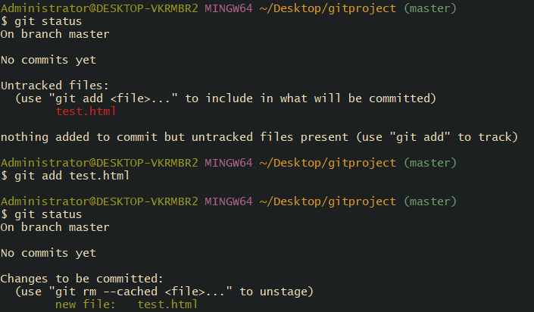
To add all files from untracked files to tracked files we use command
git a
git add . → Adds all files in the folder from untracked → tracking (staging) area.

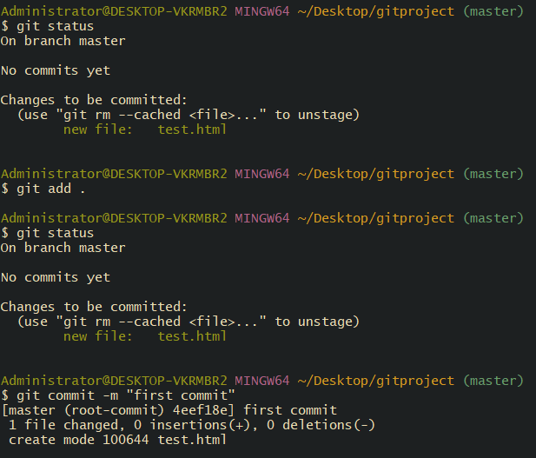

All the files have been moved to the tracking area.
To store the files in central repository we should commit
git commit -m “added couple of files to each folder”

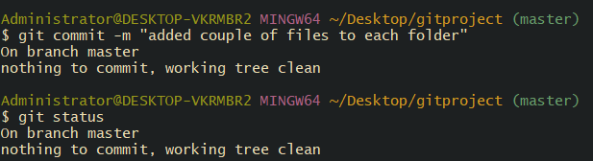
After adding files to staging area using 'git add', we commit the files using:
git commit -m "added couple of files to each folder"
This command stores all staged files into the local Git repository.

To see complete commit id details use command
git log ---- it will show complete details about commit id

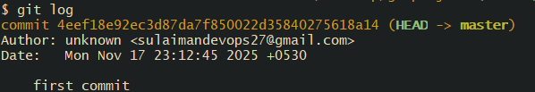
View complete commit ID details.

For every commit a unique commit id is generated.
To push your file to git hub we need to create new repository
+new ---- repository name ---- description(optional)

To add my file to repository in git hub use command
git remote add origin ssh <pate url here>

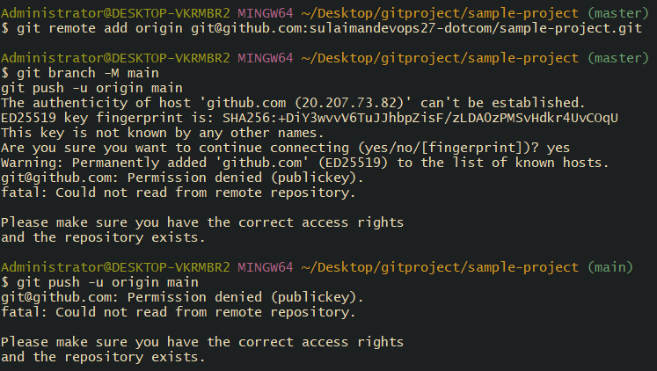

Here we can see some addresses are configured.
To connect with the remote server for github we need to provide key pair

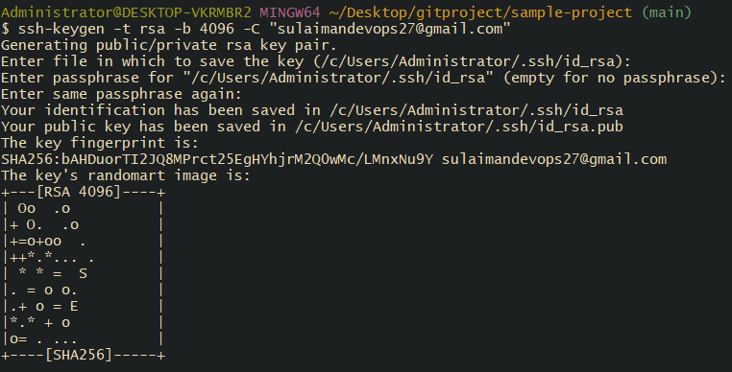

After this we need settings git hub ---- settings ---- SSH and GPG keys ---- add ssh key


We have successfully create our first sample project ..

git push -u origin master

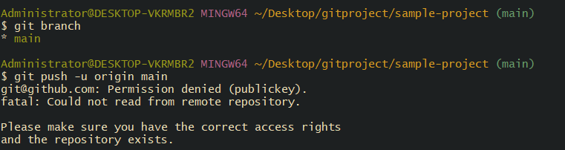

rm -rf f4
git status
git add .
git commit -m “deleted f4”
git push -u origin master
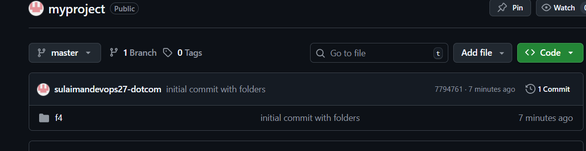

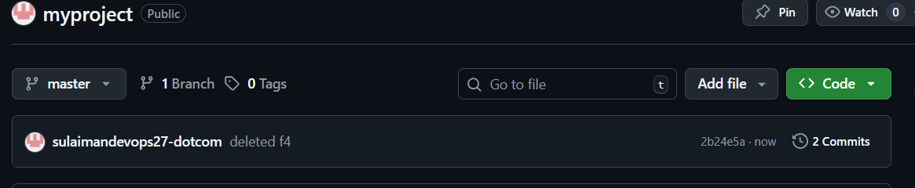

That successfully delete our f4 as it visible on our board
including creating f4, deleting it, and pushing everything to GitHub,

As see we have successfully delete our file

